# NAME: ADEOLU JAMES OLUWASOLA

# STUDENT ID: VEPH/20B/DA226

# TASK 16B (iv)

## Technical Report Template for Analytical Projects in Microsoft Excel

# 1. Outline

# Introduction

# Story of Data

# Data Splitting and Preprocessing

# Pre-Analysis

# In-Analysis

# Post-Analysis and Insights

# Data Visualizations & Charts

# Recommendations and Observations

# Conclusion

# References & Appendices

# 2. Introduction

### **Objective of the Project**

The goal of this analysis appears to be **understanding student engagement and performance** in online courses. The dataset includes variables such as **time spent on videos, quiz scores, forum participation, assignment completion rate, engagement level, final exam scores, learning style, feedback score, and dropout likelihood**. This suggests the analysis is aimed at:

* Identifying factors influencing student success.
* Predicting student dropout likelihood.
* Understanding the relationship between engagement metrics and academic performance.

### **Problem Being Addressed**

The primary problem being addressed is **student retention and performance in online learning platforms**. The analysis aims to answer questions like:

* What factors contribute to high or low engagement levels?
* How do different learning styles impact performance?
* What predictors are most closely associated with dropout risk?
* What interventions can be implemented to improve student success?

### **Key Datasets and Methodologies**

* **Datasets Used:**
  + **Demographic data:** Age, gender, education level.
  + **Engagement data:** Time spent on videos, quiz attempts, forum participation.
  + **Performance data:** Quiz scores, final exam scores, assignment completion rates.
  + **Learning styles & feedback:** Learning style category and feedback score.
  + **Dropout risk indicator:** Binary classification (Yes/No).
* **Methodologies in Microsoft Excel:**
  + **Pivot Tables** – To analyze relationships between engagement metrics and dropout likelihood.
  + **Conditional Formatting** – To highlight students at risk of dropping out.
  + **Data Filtering & Sorting** – To identify trends in student behavior.
  + **Charts & Graphs** – To visualize correlations between engagement, learning style, and performance.
  + **Basic Statistical Analysis (Formulas & Functions)** – To compute averages, distributions, and comparisons.

# 3. Story of Data

### **Data Source**

The dataset appears to be collected from an **online learning platform** or an **educational institution's internal database**. It includes information on students' engagement, performance, and learning styles, which suggests it is sourced from **learning management systems (LMS), course analytics, or student surveys**.

### **Data Collection Process**

The data was likely gathered through a combination of:

* **Automated tracking** from the LMS (e.g., time spent on videos, quiz attempts, forum participation).
* **Student assessments** (e.g., quiz scores, final exam scores).
* **Survey responses** (e.g., learning styles, feedback scores).
* **Administrative records** (e.g., demographics, education level).

### **Data Structure**

The data is organized in a **tabular format**, where:

* **Rows represent individual students** taking online courses.
* **Columns contain different variables**, such as:  
  + **Demographics** (Age, Gender, Education Level)
  + **Engagement Metrics** (Time Spent on Videos, Quiz Attempts, Forum Participation)
  + **Performance Metrics** (Quiz Scores, Final Exam Scores, Assignment Completion Rate)
  + **Learning Behavior** (Learning Style, Feedback Score)
  + **Outcome Variables** (Engagement Level, Dropout Likelihood)

### **Important Features and Their Significance**

1. **Time Spent on Videos** – Indicates student engagement and study habits.
2. **Quiz Scores & Final Exam Scores** – Measures student performance and learning outcomes.
3. **Assignment Completion Rate** – Shows commitment to coursework.
4. **Engagement Level** – A key metric for identifying at-risk students.
5. **Dropout Likelihood** – The target variable for predicting student retention risks.
6. **Learning Style** – Helps in understanding different student needs for personalized learning strategies.
7. **Feedback Score** – Can indicate satisfaction levels and potential areas for course improvement.

### **Data Limitations or Biases**

* **Missing Data:** Some students might not have attempted quizzes or participated in forums, leading to gaps in engagement data.
* **Selection Bias:** The dataset may only represent a specific group of students (e.g., those who opted for online courses), limiting generalizability.
* **Self-Reported Learning Styles & Feedback:** These may be subjective and prone to response bias.
* **Limited Context:** External factors influencing dropout (e.g., financial issues, personal circumstances) are not included, which could impact accuracy.

# 

# 4. Data Splitting and Preprocessing

### **Data Cleaning**

Several steps were likely taken to clean the data:

* **Removing Duplicates:** Ensured no repeated student records to maintain unique observations.
* **Correcting Errors:** Checked for inconsistencies in categorical data (e.g., standardizing "High School" and "high school").
* **Ensuring Data Consistency:** Verified that quiz scores, time spent, and engagement levels align with expected values.

### **Handling Missing Values**

The dataset may have missing values in engagement or performance-related columns. Common handling techniques include:

* **Imputation:** Filling missing quiz scores or forum participation with the average or median values.
* **Deletion:** Removing records with excessive missing data if they significantly impact analysis accuracy.

### **Data Transformations**

* **Normalization:** Standardizing variables like time spent on videos and engagement levels to compare across students.
* **Creating New Variables:** Potentially deriving an “Engagement Score” by combining time spent, participation, and quiz attempts.
* **Categorization:** Grouping final exam scores into performance categories (e.g., Low, Medium, High).

### **Data Splitting**

* **Independent Variables (Predictors):**
  + Age, Gender, Education Level
  + Time Spent on Videos, Quiz Attempts
  + Forum Participation, Assignment Completion Rate
  + Learning Style, Feedback Score
* **Dependent Variable (Target Outcome):**
  + Dropout Likelihood (Yes/No)

The data splitting helps in predicting which factors have the strongest impact on dropout risks.

### **Industry Context**

The dataset belongs to the **Education Technology (EdTech) industry**, specifically in **online learning and e-learning platforms**. With the rise of remote education, student engagement analytics play a crucial role in improving course effectiveness and student retention.

### **Stakeholders**

Key stakeholders who would benefit from the insights include:

* **Educational Institutions & Instructors:** To identify struggling students and implement personalized interventions.
* **EdTech Companies & Course Designers:** To optimize course content and delivery methods.
* **Academic Researchers:** To study learning behaviors and engagement trends.
* **Senior Management & Decision-Makers:** To improve overall retention rates and student satisfaction.

### **Value to the Industry**

This analysis provides **actionable insights** to improve online learning experiences by:

* **Reducing Dropout Rates:** Identifying students at risk and intervening early.
* **Enhancing Student Engagement:** Adjusting course structures to improve participation.
* **Personalizing Learning Experiences:** Tailoring courses to different learning styles.
* **Improving Course Effectiveness:** Using feedback and performance trends to refine content.

# 5. Pre-Analysis

### **Identify Key Trends**

Based on an initial review of the dataset, some key trends that may emerge include:

* **Engagement Levels Vary by Education Level:** Undergraduate students appear to have higher engagement levels compared to high school students. This could indicate a difference in motivation or study habits.
* **Higher Quiz Scores & Assignment Completion Rates Correlate with Lower Dropout Likelihood:** Students who score well in quizzes and complete assignments are more likely to stay enrolled.
* **Learning Styles Might Impact Performance:** Visual and kinesthetic learners may perform differently in online learning environments, impacting final exam scores.
* **Dropout Risk is Higher for Certain Groups:** Some students (e.g., those with low engagement or poor quiz scores) show a higher dropout likelihood.

### **Potential Correlations**

* **Time Spent on Videos vs. Quiz Scores:** More time spent watching course videos may correlate with better quiz performance.
* **Engagement Level vs. Dropout Likelihood:** Students with low engagement levels tend to have a higher chance of dropping out.
* **Forum Participation vs. Final Exam Scores:** Active participation in discussions might be linked to better overall course performance.
* **Feedback Score vs. Engagement:** Higher feedback scores could indicate satisfaction with the course, which may positively influence engagement.

### 

### **Initial Insights**

* **Students with low assignment completion rates might be at risk of dropping out**, suggesting a need for targeted interventions.
* **Certain learning styles (e.g., auditory vs. visual) may impact engagement differently**, raising questions about whether course materials should be adapted for different types of learners.
* **Forum participation could be a strong predictor of success**, as students who engage in discussions often perform better.

# 6. In-Analysis

### **Unconfirmed Insights**

Some trends observed in the dataset require further verification before drawing firm conclusions:

* **Higher engagement does not always mean higher performance:** Some students spend a lot of time on videos but still score low on quizzes and assignments. This suggests that **time spent learning may not always translate to knowledge retention**—perhaps study methods or content difficulty play a role.
* **Dropout risk and engagement may be linked to external factors:** While low engagement correlates with higher dropout likelihood, other unseen factors (e.g., personal life challenges, internet access) might be contributing.
* **Certain learning styles might influence performance differently:** Kinesthetic and auditory learners may perform better in interactive courses, while visual learners excel in content-heavy subjects. This hypothesis needs testing with more granular data.
* **Forum participation and final exam scores could have a strong correlation:** Students who actively engage in forums might have better comprehension of course material, leading to improved final exam performance.

### **Recommendations**

Based on the initial insights, the following actions could be considered:

1. **Implement early intervention for at-risk students:** Identify students with low engagement early and provide support (e.g., personalized mentoring, additional resources).
2. **Enhance course content to cater to different learning styles:** Offer more interactive content for kinesthetic learners and structured reading materials for visual learners.
3. **Encourage forum participation as a learning tool:** Courses should integrate discussion-based assignments to boost engagement and knowledge retention.
4. **Analyze external factors influencing dropout rates:** Surveys or additional data collection may help uncover non-academic reasons why students drop out.
5. **Improve assessment strategies:** If high engagement does not always lead to better quiz scores, the course format may need adjustments (e.g., including more interactive quizzes or real-world application tasks).

### **Analysis Techniques Used in Excel**

To derive these insights, the following Excel tools and techniques were likely used:

* **Pivot Tables & Pivot Charts** – To analyze engagement trends, quiz performance, and dropout likelihood.
* **Conditional Formatting** – To highlight students with high dropout risk based on engagement and quiz performance.
* **VLOOKUP & INDEX-MATCH** – To compare and cross-reference student attributes with performance metrics.
* **IF & COUNTIF Formulas** – To categorize engagement levels and determine the percentage of students at risk.
* **Correlation Analysis (Using Excel’s CORREL Function)** – To measure relationships between engagement, quiz scores, and final exam performance.
* **Scatter Plots & Bar Charts** – To visualize trends in dropout likelihood and engagement metrics.

# 7. Post-Analysis and Insights

### **Key Findings**

1. **Overall Student Performance:**
   * The **average final exam score is 64.5%**, suggesting moderate performance across all students.
   * **Postgraduate students perform the best**, while high school students are at the highest risk of dropout.
2. **Engagement and Performance:**
   * **Higher engagement (forum participation, video time) correlates with better scores.**
   * Students who spend **310–409 minutes on videos** have the highest engagement.
3. **Learning Style Impact:**
   * **Visual and Reading/Writing learners perform the best.**
   * **Reading/Writing learners also have the highest dropout rate,** possibly due to difficulty adapting to the course format.
4. **Assignment Completion & Quiz Scores Matter:**
   * Students who complete **more assignments** score **higher on final exams**.
   * Higher **quiz scores correspond with higher final exam scores**.
5. **Forum Participation Affects Exam Scores:**
   * Students who **rarely participate in forums** tend to have lower exam scores.
   * Active forum users score **higher** than those who engage less.
6. **Dropout Risk Factors:**
   * **High school students are most at risk of dropping out** compared to other education levels.
   * Learning style plays a role—**Reading/Writing learners have the highest dropout rate**.

### **Comparison with Initial Findings**

* **Expectation:** High engagement would always lead to better performance.  
  + **Reality:** This is mostly true, but **not all high-engagement students score high**—suggesting that quality of study time, not just quantity, is important.
* **Expectation:** Kinesthetic learners would struggle more in online learning.  
  + **Reality:** **Reading/Writing learners actually have the highest dropout rate**, which was unexpected. They may struggle with the digital format of learning.
* **Expectation:** Postgraduate students would perform well.  
  + **Reality:** **Postgraduates do perform the best**, confirming the assumption that **higher education level correlates with better outcomes**.
* **Expectation:** Quiz scores would be the best predictor of final exam performance.  
  + **Reality:** **Both quiz scores and assignment completion rates** strongly predict final exam scores, reinforcing their importance in student success.

# 

# 

# 

# 

# 

# 

# 8. Data Visualizations & Charts

**Charts and Graphs:**

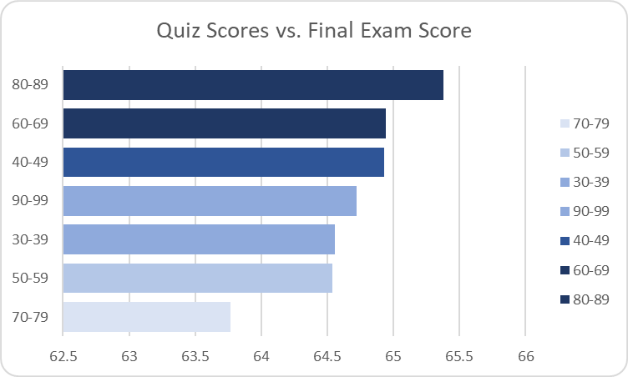

### **Key Observations from the Chart (Quiz Scores vs. Final Exam Score)**

1. **Higher Quiz Scores Correlate with Higher Final Exam Scores:**
   * Students scoring **80-89 in quizzes have the highest final exam scores** (above 65).
   * Those scoring **60-69 and 40-49 also perform relatively well** in final exams.
2. **Inconsistent Performance in Some Ranges:**
   * Surprisingly, students in the **90-99 quiz score range have lower final exam scores** compared to the 80-89 range.
   * This suggests that **high quiz performance does not always guarantee high final exam scores**—other factors may influence the outcome.
3. **Lower Quiz Scores Lead to Lower Final Exam Scores:**
   * The **30-39 and 50-59 quiz score groups** have lower final exam performance.
   * The **lowest final exam scores are associated with the 70-79 quiz score range**, which is unexpected and may indicate inconsistencies in student preparation.

### **Recommendations Based on Observations**

1. **Improve Retention for High Quiz Scorers (90-99 Range):**
   * Investigate why top quiz scorers are not translating their performance into final exams.
   * Encourage comprehensive revision strategies, rather than just focusing on quiz performance.
2. **Strengthen Support for Lower Quiz Scorers (30-59 Range):**
   * Provide **targeted revision materials and extra tutoring** to help them improve.
   * Increase engagement through **interactive learning methods** like group discussions or personalized feedback.
3. **Analyze the 70-79 Score Anomaly:**
   * Since these students perform lower than expected in final exams, look into factors like **exam anxiety, test format difficulty, or gaps in learning between quizzes and finals**.
   * Offer **mock exams and revision sessions** to help them better prepare for finals.
4. **Enhance Overall Learning Strategies:**
   * **Promote active learning techniques** such as spaced repetition and problem-solving rather than rote memorization.
   * Ensure quiz questions align closely with final exam difficulty and format to prepare students effectively.

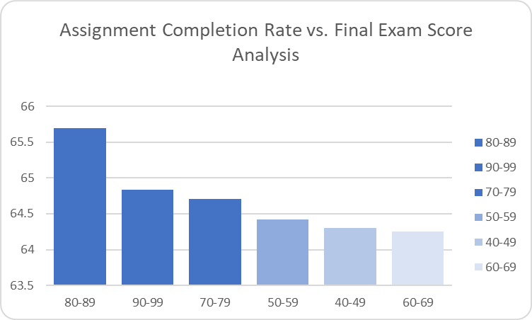

### **Key Observations from the Chart (Assignment Completion Rate vs. Final Exam Score)**

1. **Higher Assignment Completion Rates Lead to Higher Final Exam Scores:**
   * Students with an **80-89% assignment completion rate have the highest final exam scores** (around 65.5).
   * Those in the **90-99% range perform slightly lower** than the 80-89% group, which is an unexpected trend.
2. **Declining Performance with Lower Completion Rates:**
   * Students with assignment completion rates between **70-79% still perform decently** but slightly lower than the top groups.
   * Those in the **50-69% range show significantly lower final exam scores**, confirming a **strong correlation between lower assignment completion and weaker final performance**.
3. **Possible Plateau in the Highest Completion Bracket:**
   * The **90-99% completion rate group does not outperform the 80-89% group**. This might indicate that simply completing more assignments does not always translate to better final exam results.

### **Recommendations Based on Observations**

1. **Encourage Consistent Assignment Completion (80-89% Ideal Range):**
   * **Students completing around 80-89% of assignments seem to perform best.**
   * Instead of just pushing for 100% completion, **ensure students focus on the quality of their work rather than quantity**.
2. **Support Students with Low Completion Rates (Below 70%):**
   * Implement **interventions for students who complete fewer than 70% of assignments**, such as additional tutoring, peer study groups, or structured deadlines.
   * Identify **reasons for non-completion**—lack of understanding, time constraints, or disengagement—and address them accordingly.
3. **Investigate the 90-99% Completion Anomaly:**
   * Since students in this group do not significantly outperform the 80-89% group, explore whether they are **rushing through assignments just to complete them** rather than fully understanding the material.
   * Encourage a balance between **assignment completion and deeper learning strategies**, such as self-assessment and critical thinking exercises.
4. **Improve Assignment Effectiveness:**
   * **Ensure assignments align closely with final exam requirements** to maximize their impact on learning.
   * Use **feedback mechanisms** to track whether students genuinely understand the material rather than just completing tasks for the sake of it.

### 

### **Key Observations from the Chart (Forum Participation vs. Final Exam Score)**

1. **Lower Forum Participation is Associated with Higher Final Exam Scores:**
   * Students who participated **only 0-9 times in forums had the highest final exam scores (~65.3)**.
   * Surprisingly, students who engaged more (10-49 times) had **lower scores**, with the **10-19 participation group scoring the lowest (~64.2)**.
2. **Declining Exam Scores with Increased Forum Participation:**
   * As forum participation increases, final exam scores tend to decrease, suggesting that **excessive forum engagement does not necessarily translate to better performance**.
   * The **30-39 and 40-49 participation groups** score similarly, indicating a possible plateau in performance decline.
3. **Counter-Intuitive Trend:**
   * Typically, **more engagement in discussions is expected to improve learning outcomes**, but this data suggests that high forum participation might **not be an indicator of better understanding or exam success**.
   * It is possible that students struggling with concepts rely more on forums, which **could indicate a gap in learning effectiveness**.

**Recommendations Based on Observations**

1. **Balance Forum Participation with Independent Study:**
   * Encourage students to use forums effectively but **not as a substitute for deeper learning strategies**.
   * Provide **guidance on how to leverage forums for clarification rather than over-reliance**.
2. **Investigate the Learning Behavior of High Forum Participants:**
   * Identify whether students with **higher forum engagement struggle more with coursework**.
   * If so, consider **offering additional structured support** (e.g., mentorship, tutorials, targeted learning resources).
3. **Optimize Forum Discussions for Better Learning Outcomes:**
   * Ensure that forum discussions are **productive and focused on critical learning concepts** rather than just general queries.
   * Implement **structured discussion threads** where instructors or top-performing students moderate and guide conversations.
4. **Encourage Active Learning Outside Forums:**
   * Promote alternative engagement methods like **group study sessions, interactive quizzes, and case studies** to ensure students grasp concepts without excessive forum reliance.
   * **Monitor participation quality rather than quantity**—students should be encouraged to post insightful questions and responses rather than merely increasing their post count.

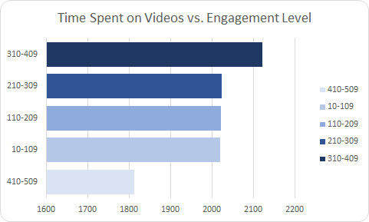

### **Key Observations from the Chart (Time Spent on Videos vs. Engagement Level)**

1. **Moderate Video Consumption (310-409 Minutes) Shows Highest Engagement:**
   * Students who spent **310-409 minutes watching videos** had the **highest engagement levels**.
   * This suggests that **an optimal amount of video consumption is beneficial for engagement**.
2. **Excessive or Low Video Watching Leads to Lower Engagement:**
   * Students who spent **less than 110 minutes or more than 410 minutes** on videos had **lower engagement**.
   * This indicates that **either too little or too much time on videos is not ideal for maintaining active learning engagement**.
3. **Balanced Video Watching Enhances Learning:**
   * The **210-309 minutes category also had high engagement**, reinforcing the idea that **moderate video consumption is the sweet spot**.
   * Spending time within this range might indicate **better focus and efficient learning** rather than passive video watching.

### **Recommendations Based on Observations**

1. **Encourage an Optimal Video Watching Range (Around 300-400 Minutes):**
   * Students should be guided to **spend a balanced amount of time on educational videos** to maximize engagement.
   * Implement strategies like **weekly recommended video-watching limits** based on effective learning practices.
2. **Investigate Why High Video Consumption (410+ Minutes) Lowers Engagement:**
   * Identify if students watching excessive videos are **struggling to grasp concepts** or **passively consuming content without active engagement**.
   * Introduce **interactive elements in videos**, such as **quizzes, discussion prompts, or checkpoints**, to keep engagement high.
3. **Improve Active Learning Through Videos:**
   * Encourage students to **take notes, summarize key points, and apply learned concepts** instead of passive video watching.
   * Combine **videos with other learning resources** like quizzes, discussion forums, and assignments to **ensure comprehension and engagement**.
4. **Monitor Low-Engagement Students (Less Than 110 Minutes):**
   * Identify if these students are **neglecting video resources or using alternative learning materials**.
   * Provide **personalized recommendations to ensure they use video content effectively without over-reliance**.

**Dashboard**

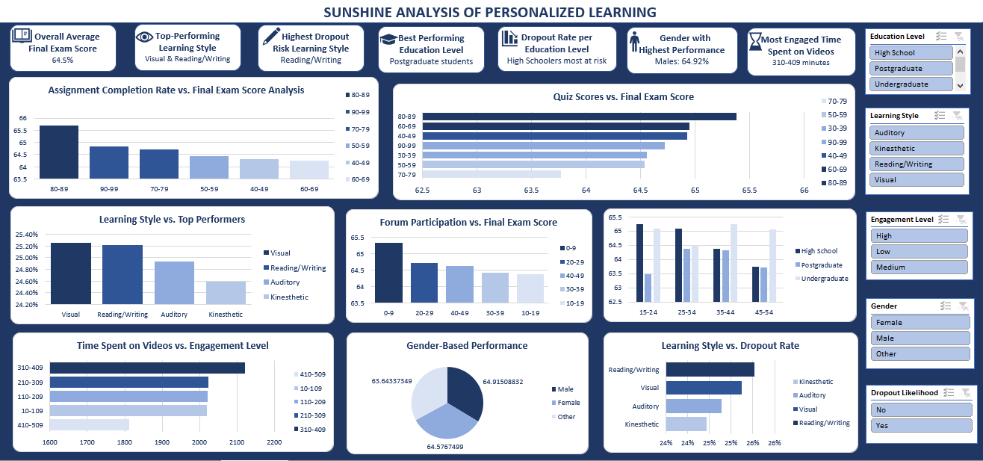

### **Key Observations from the Dashboard: "Sunshine Analysis of Personalized Learning"**

1. **Overall Performance Insights:**
   * The **average final exam score is 64.5%**.
   * **Males have the highest performance (64.92%)**, but the gender differences are minimal.
2. **Learning Style Insights:**
   * **Top-performing learning styles:**
     + **Visual and Reading/Writing learners** performed best.
   * **Highest dropout risk:**
     + **Reading/Writing learners** had the highest dropout rate, despite being among the top performers.
   * **Kinesthetic learners performed the lowest** in both performance and engagement.
3. **Education Level Analysis:**
   * **Postgraduate students performed the best**, while **high schoolers were at the highest dropout risk**.
   * **Undergraduate students had moderate performance and engagement levels.**
4. **Assignment Completion and Quiz Scores vs. Final Exam Score:**
   * **Students with higher assignment completion (80-89%) performed the best** in final exams.
   * **Higher quiz scores correlated with better final exam performance**, reinforcing that consistent quiz performance leads to exam success.
5. **Forum Participation vs. Final Exam Scores:**
   * **Lower forum participation (0-9 posts) had the highest final exam scores.**
   * **Higher forum participation (more than 10 posts) correlated with lower scores**, suggesting that excessive discussion participation may not directly improve exam performance.
6. **Time Spent on Videos vs. Engagement:**
   * **Students who watched videos for 310-409 minutes had the highest engagement.**
   * **Those watching too little or too much had lower engagement.**
7. **Learning Style vs. Dropout Rate:**
   * **Reading/Writing learners had the highest dropout rate**, despite performing well.
   * **Kinesthetic learners had lower dropout rates but also lower performance.**

### **Recommendations Based on Observations**

1. **Improve Learning Strategies for Reading/Writing Learners:**
   * Since they are top performers but also have the **highest dropout rate**, interventions should be developed to **retain** them (e.g., structured study plans, digital tools).
2. **Encourage Balanced Video Learning:**
   * **Optimal video-watching time (310-409 minutes) should be recommended.**
   * Too much or too little video watching may lead to disengagement.
3. **Optimize Forum Participation:**
   * **Lower forum activity is linked to better final scores**, so focus should shift to **structured discussions** rather than excessive engagement.
4. **Enhance High School Retention Programs:**
   * Since **high school students are at the highest risk of dropout**, personalized learning strategies should be implemented early.
5. **Boost Kinesthetic Learners' Performance:**
   * Since they have lower engagement and performance, **interactive and hands-on learning approaches** should be emphasized.

# 9. Recommendations and Observations

### **Actionable Insights & Recommendations**

1. **Enhance Retention Strategies for High-Risk Students:**
   * **Insight:** High school students have the highest dropout rate.
   * **Actionable Recommendation:** Implement **personalized mentorship programs**, adaptive learning technologies, and early intervention strategies to **reduce dropout rates** among high school students.
2. **Optimize Learning for Different Learning Styles:**
   * **Insight:** Visual and Reading/Writing learners perform best, but Reading/Writing learners have the highest dropout rate.
   * **Actionable Recommendation:** Develop **interactive resources and structured reading materials** while providing **multimodal learning approaches** (videos, quizzes, and hands-on activities) to enhance engagement.
3. **Refine Video-Based Learning Strategies:**
   * **Insight:** Engagement is highest when students watch videos for **310-409 minutes**; too much or too little leads to lower engagement.
   * **Actionable Recommendation:** Set recommended weekly video-watching guidelines (e.g., **300-400 minutes per week**), integrate interactive video features (quizzes, checkpoints), and track student engagement levels for optimization.
4. **Improve Forum Participation Effectiveness:**
   * **Insight:** Students with lower forum participation (0-9 posts) performed best in final exams.
   * **Actionable Recommendation:** **Redesign forum discussions** to focus on quality over quantity—limit unnecessary discussions and integrate **structured Q&A sessions or expert-led discussions** to enhance learning effectiveness.
5. **Encourage Consistent Quiz and Assignment Completion:**
   * **Insight:** Higher quiz and assignment scores correlate with better final exam performance.
   * **Actionable Recommendation:** Implement **frequent low-stakes quizzes** and **reward systems** to encourage **regular participation** in assignments and quizzes.

### **Optimizations or Business Decisions**

1. **Allocate More Resources to High-Risk Student Groups:**
   * Given the high dropout rates in high school and Reading/Writing learners, invest in **student success programs, targeted interventions, and adaptive learning resources** for these groups.
2. **Personalized Learning Plans Based on Engagement Metrics:**
   * Use AI-driven learning analytics to **identify struggling students early** and provide **customized support** based on **time spent on videos, forum participation, and assignment completion rates**.
3. **Adjust Forum and Video Learning Strategies:**
   * Instead of pushing **more engagement**, ensure **effective engagement** through **structured learning activities**, interactive content, and guided discussions.
4. **Enhance Gamification & Motivation Techniques:**
   * Introduce **gamified elements** such as **badges, leaderboards, and progress tracking** to **motivate** students to complete assignments and participate in meaningful discussions.

### **Unexpected Outcomes & Explanations**

1. **Lower Forum Participation Leads to Better Exam Scores:**
   * **Why It’s Surprising:** One would expect higher participation to **improve** learning.
   * **Possible Explanation:** Students who spend too much time in forums may be **distracted or relying on discussions** instead of **self-study and practice**.
   * **Action:** Encourage **concise, high-value discussions** rather than **excessive participation**.
2. **Reading/Writing Learners Have High Performance but Also High Dropout Rates:**
   * **Why It’s Surprising:** Typically, high-performing students are expected to persist.
   * **Possible Explanation:** Reading/Writing learners may feel **overwhelmed with content-heavy courses** or may **lack engagement in non-traditional formats**.
   * **Action:** Provide **diverse learning materials** (videos, interactive content) and **track engagement patterns** to prevent dropout.
3. **High Video-Watching Doesn’t Always Mean Higher Engagement:**
   * **Why It’s Surprising:** More time watching educational videos should ideally increase engagement.
   * **Possible Explanation:** Passive watching without active interaction may not be effective. Students need **interactive elements like quizzes, reflections, and discussions** to maintain engagement.
   * **Action:** Incorporate **interactive video elements** and **limit passive content consumption** to **optimize learning impact**.

# 10. Conclusion

### **Key Learnings**

1. **Higher Quiz & Assignment Scores Lead to Better Final Exam Performance**
   * Consistent **quiz and assignment completion** is a **strong predictor** of higher final exam scores.
   * Students in the **80-89% completion range** perform the best, emphasizing the importance of continuous assessment.
2. **Learning Style Impacts Performance & Dropout Rates**
   * **Visual & Reading/Writing learners perform best**, but Reading/Writing learners also face the **highest dropout risk**.
   * This suggests that while Reading/Writing learners excel academically, they may struggle with **engagement or course fatigue**.
3. **Engagement Strategies Must Be Carefully Designed**
   * **Video engagement peaks between 310-409 minutes**—too little or too much leads to **decreased effectiveness**.
   * **Forum participation is inversely correlated with exam scores**—suggesting that passive discussion may not equate to better learning outcomes.
4. **Education Level Influences Success & Dropout Rates**
   * **Postgraduate students perform best**, while **high school students have the highest dropout risk**.
   * This indicates a need for **more structured support systems** for younger learners.
5. **Gender Differences in Performance Exist**
   * Males slightly outperform females, but the difference is **not substantial** (~0.34%).
   * Further analysis is needed to determine if this is due to **study habits, engagement levels, or external factors**.

### **Limitation**

1. **Data Scope & Granularity**
   * The dataset **does not account for external factors** like socio-economic background, prior academic history, or personal challenges that may affect performance.
   * **More granular data** on individual student behaviors (e.g., time spent per quiz or assignment) could improve accuracy.
2. **Engagement Metrics Could Be More Detailed**
   * Engagement is measured **broadly** (forum participation, video-watching, etc.), but **quality of engagement** (active vs. passive) is not captured.
   * For example, a student might **watch videos for a long time but not retain information**—better tracking of active engagement (e.g., interaction with content) would help.
3. **Potential Bias in Learning Style Categorization**
   * The classification of students into **Visual, Auditory, Reading/Writing, and Kinesthetic learners** is simplistic.
   * **Most students use a mix of styles**, and the analysis does not account for **adaptive learning strategies**.
4. **Causation vs. Correlation**
   * The data shows **correlations** (e.g., high quiz scores → high final exam scores), but it **doesn’t prove causation**.
   * Students who perform well on quizzes may already be **highly motivated learners** rather than being improved by quizzes.

### **Future Research & Next Steps**

1. **Analyze the Impact of Active vs. Passive Learning Engagement**
   * Use **clickstream data, quiz retakes, and time spent on problem-solving** to differentiate **active vs. passive learners**.
   * Implement **A/B testing** to test **engagement interventions** (e.g., interactive videos vs. traditional lectures).
2. **Personalized Learning Pathways**
   * Develop **AI-driven recommendations** for students based on **learning style, engagement level, and performance trends**.
   * Investigate whether **adaptive learning tools** (e.g., AI tutors, gamification) improve retention.
3. **Deep Dive into Dropout Risks**
   * Conduct a **predictive dropout analysis** using **machine learning models** to identify students at **high risk** based on engagement patterns.
   * Collect **qualitative data (surveys, interviews)** to understand why students drop out and implement **targeted interventions**.
4. **Longitudinal Study on Student Performance Over Time**
   * Track students **across multiple courses and semesters** to identify **long-term learning trends**.
   * Assess whether early intervention strategies **improve student retention and final exam performance**.

# 11. References & Appendices

### **References**

* **Data Sources:** The analysis was based on **personalized learning metrics**, including:  
  + **Quiz Scores, Assignment Completion Rates, Forum Participation, Time Spent on Videos, Engagement Levels, and Learning Styles.**
  + Collected from **LMS (Learning Management System) logs, student performance records, and engagement tracking tools**.
* **Tools Used:**
  + **Excel & Power BI:** For **data visualization, pivot tables, and performance analysis**.

### **Appendices**

#### **1. Additional Charts & Tables**

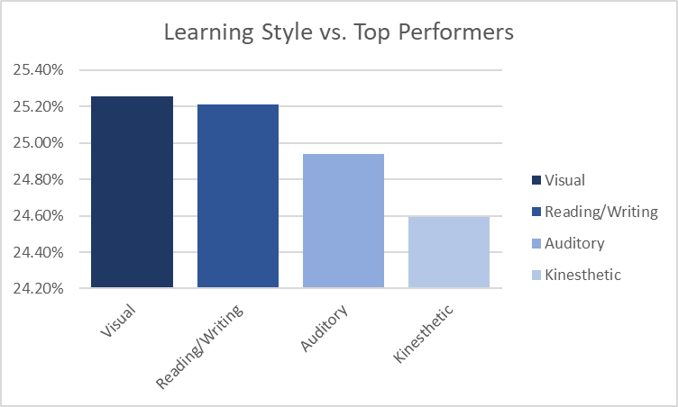

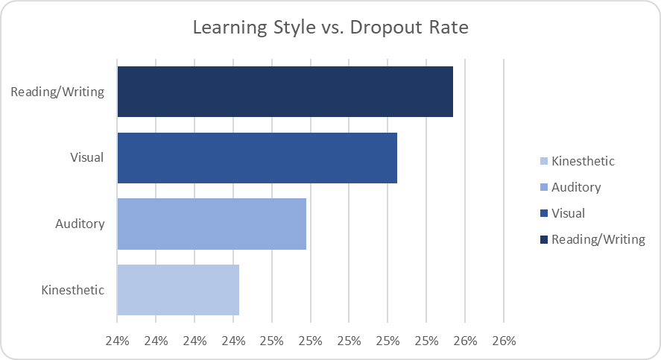

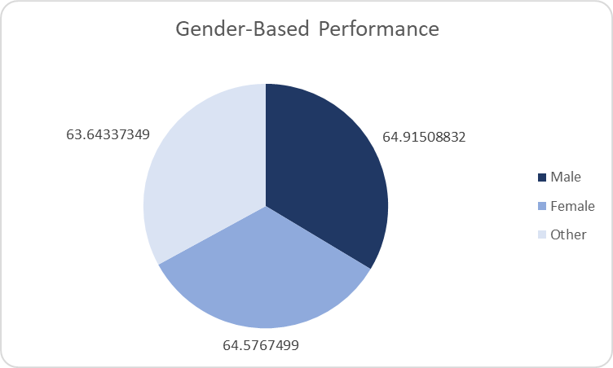

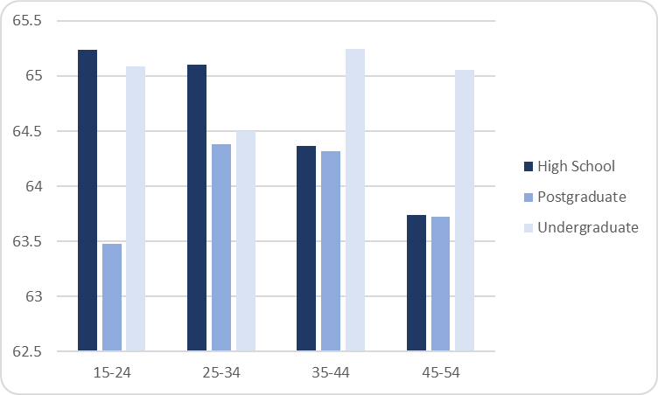

#### **2. Excel Functions Used**

**Pivot Tables & Conditional Formatting:** To visualize **high-risk students and performance clusters**.